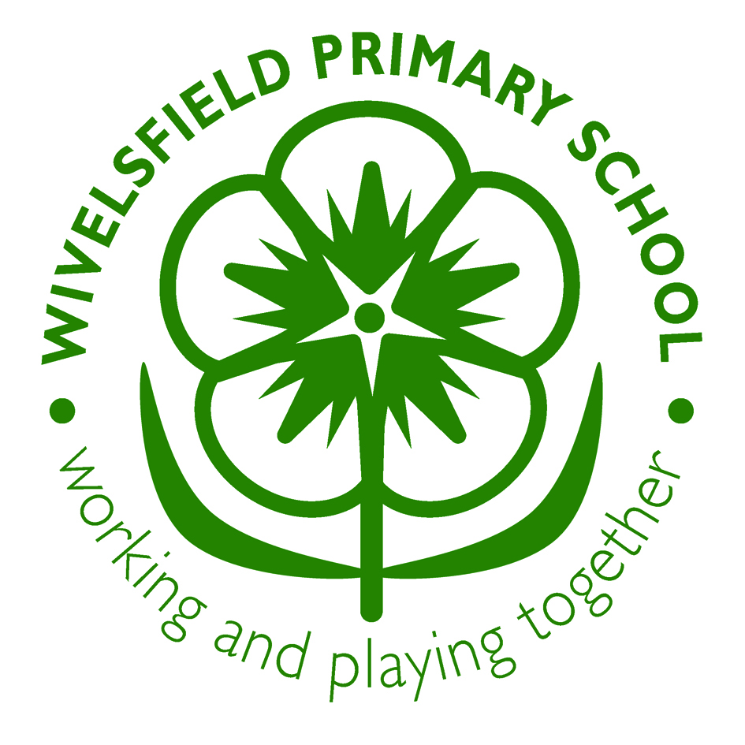
Wivelsfield School Marking Policy

This policy forms part of a whole school policy for teaching and learning. It relates to the ethos of the school and has direct links with curriculum planning and assessment.

Rationale

How children’s work is received and marked and the nature of feedback given to them will have a direct bearing on learning attitudes and future achievements. Marking is an integral part of assessment. We aim to provide a system of marking that is consistent and continuous across each stage within our school. Marking will inform planning, be diagnostic and enhance children’s learning by ultimately offering guidance on how work can be improved. Effective marking should help the child to recognise their difficulties and mistakes and encourage them to accept help/guidance from others. We aim to mark positively whenever possible to enhance self-esteem and confidence.

Marking will also be used to inform children, parents, colleagues and other interested parties.

Effective marking should:-
- Inform children of their achievements; the next steps in their learning and address any misconceptions.
- Show work is valued
- Evaluate and assess children’s learning and so Inform future planning
- Help parents to understand the strengths and areas to develop in their children’s work
- Motivate

It may also be used to model and show expectations of achievement

Marking Principles and Practice
If children are to develop as independent learners, with an awareness of their own strengths as well as areas for development (learning targets/wishes) it is essential that:

- They are made aware of the learning intentions of tasks/lessons and of the success criteria against which their work will be marked/assessed. ‘This is what we are learning and this is how I will be marking it.’
- The learning needs of individual children are understood and work is differentiated and marked appropriately.
- Where appropriate marking/feedback (verbal or written) is linked directly to lesson success criteria.
- Work should be marked with the use of the same marking code (Appendix 1) across the school. This should be displayed in KS1 and KS2 classes and available on tables/in books when children are returning to /correcting their work
- Marking should always be able to move learning forward.
- Green pens to be used for marking
- Use of a child’s name in a written comment personalises it.
- Teachers writing to be neat and legible.
- When possible, teaching assistants mark work of children they have been working with. It will always be seen by the teacher.
- Marking should require children to respond. Children respond to marking in purple pen
- Sufficient time on a regular basis must be found for children to respond to marking. This may vary in line with the age of different classes
- Short term supply teachers mark work, but not ‘in-depth’
- If an adult has worked with a child (parent or volunteer) work may be stamped as adult assisted.
- A particularly successful piece of work may be awarded with a house point/ head teachers award credit in line with the school’s system of rewards

Correcting mistakes has its place in marking when it contributes to an improvement in a pupil’s work. Errors need to be pointed out if a child is to improve his/her work; which errors and how many will depend on many factors. In the case of foundation stage and KS1 pupils, feedback needs to be as immediate as possible. This should be noted on the work and be related to the learning objectives and/or personal targets.

Oral feedback

Immediate feedback is the most effective feedback and is therefore most likely to be oral. Oral feedback is more powerful and has maximum impact when pointing out successes and improvement needs against learning intentions and targets. It is usually interactive and developmental. It may give reassurance or a quick check on progress. The effect of teacher comments will be seen in a child’s response in moving on to the next learning step.

The code VF will be written on a piece of work to signify that oral/verbal feedback has been given. Children will be encouraged to continually engage in a dialogue about their learning with their teachers/teaching assistants.

Corrections

- Corrections will be completed underneath or nearby to work in purple pen or pencil
- Once work has been marked, rubbers may not be used for corrections.
- Rubbers must not be used in maths books (errors can show children moving on as learners)
- Errors will be neatly crossed out with a pencil.
- Children or adults will record VF on work to show that misconceptions have been explained.

Involving children in marking

Self-marking/evaluation against shared learning intentions can help empower a child, therefore children should be encouraged to evaluate their own work before marking, taking into consideration the shared learning objectives and any previously individually set targets in their books. Wherever possible marking will take place with the children.

Ideally marking should become a part of the developing dialogue resulting in pupil progress: For example, a pupil writes, the writing is marked away from the pupils and in his/her subsequent work, the pupil incorporates suggestions and/or corrects mistakes in that piece of work. This is best done during a unit of work i.e. formative rather than summative.

- Children may mark their own work but teachers will always scrutinise it.
- Peers may mark each other’s work prior to the teacher marking it, following an agreed system. Sharing work with the whole class or group can be very helpful
- Children should be encouraged to reflect after marking and take the opportunity to correct, practise or investigate a problem.
- Children to respond to feedback using purple pens/pencils in all books.
- Teachers to acknowledge/respond to children’s purple pen responses
- Time will be timetabled at least weekly to enable children to have the opportunity to return to their work and to respond to comments/wishes. Examples of time allocations could be: morning tasks, in planned lesson time or/and during reading group rotations.

Frequency of marking

We constantly assess the children’s work, establishing their achievements. This may be as simple as recognition of a learning objective being achieved.
Children’s work to be marked:
- As far as possible, informal marking (verbal/on-going using marking code) will be done as work is created.
- Recognition of achievement against learning outcome to be noted using a star
- Use of success criteria tick chart can be useful formative feedback (see Appendix two example)
- Teachers need to look at work to inform on-going assessments.
- As far as possible, time will be spent with the child to ensure they understand the comments
and the targets set.

English

During the draft or edit stage of writing, a teacher should generally record successes and ways forward e.g. two stars “” relevant to the success criteria and one “wish” . This could also be recorded using a success criteria chart. Dependent on the nature of the target “wish”, the child may return to that piece of work to improve it or ensure it is applied in the next piece. In EYFS these will be recorded as verbal feedback. This type of ‘deeper marking’ must be undertaken on a draft/major outcome of work as per unit of English.

Maths/Science

The minimum expectation for marking is acknowledgement of progress against the learning objective as well as marking stated in the code. Wishes or targets may be recorded if appropriate. Oral feedback is likely to be used in greater amounts in these books.

Topic work

Written comments on topic work may focus purely on recognition of successes and commending effort as more ‘deeper’ marking may have been used in the draft stages of this writing found in other books.

Agreed: Signed_____________________________ Dated___________________

Review Date November 2018

CP suggested English revision 4.9.17:
All adults working with chn should be recording in green pen in books as they work with the chn on a daily basis. This marking should include the use of VF, and the marking code symbols, and include such things as spellings (up to a maximum of 3) identified for correction or attention drawn to ‘sense’. During the draft or edit stage of writing, a teacher should generally record successes and ways forward e.g. two stars “” relevant to the success criteria and one “wish” . This type of ‘deeper marking’ must be undertaken a minimum of once per week and must be on a major outcome of work as per unit of English.

Appendix 1
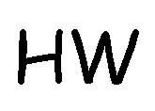
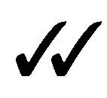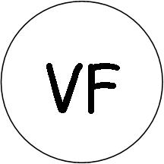
Target Achieved

Missing Punctuation or Capital Letter
Target/ Wish
New Line or Paragraph
Handwriting
Maths
Language
Wivelsfield Marking Code

Sentence
Structure
Vocab, Connectives, Openers, Punctuation
Good Idea
Presentation

Incorrect
Correct
General
Verbal Feedback

A
Assisted
EYFS only: I = Independent A = adult support AL = Adult Led CI - Child Initiated

Incorrect - try again
One Digit Per Box

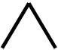
Incorrect Spelling
Missing Word

Finger Space

? Check for Sense

Appendix 2

I am learning to …………

I am learning to …………

Success criteria: Self A Peer A Teacher A

Today I have learnt……………….

Next time I will……………………….

NB: KS1 will generally only use self and peer assessed

