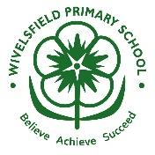
English: Lila and the secret of rain
Design and Technology: constructing working drawbridges
Maths: Fractions, Time, Statistics, Position & Direction
Science: Plants
Geography: What is it like to live by the coast?

Science Vocabulary:
soil compost roots stem leaves flower petal spring summer seed bean bulb germinate grow sunlight water air lifecycle
Cross-curricular links:

Learning events:

- Trip to Hever Castle
- Class Assembly
- Constructing working drawbridges
What is a Monarch?
Key questions:
Who is our monarch today?
How did William the Conqueror become king of England?
How did castles change?
How has the role of a monarch changed over time?

Key vocabulary:

King Queen monarchy power
anoint coronation crowing
kingdom castle battle moat
stone keep tower motte
drawbridge defend

