Early Years
Books are subject to change, depending on dates and the children’s interests and needs.
Term 1 | All About Me  Transition, Emotions, Families, Bodies, Senses, Traditional Tale: The Enormous Turnip
Term 1 | 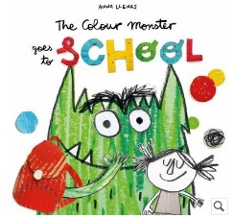 | 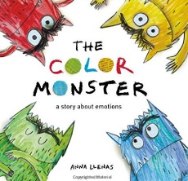 |  | 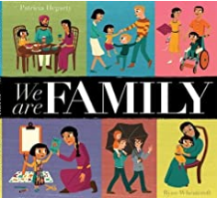 |  | 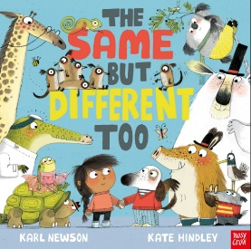 |  | 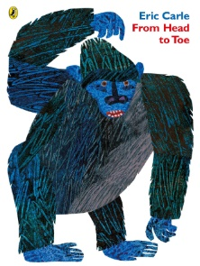 |  | 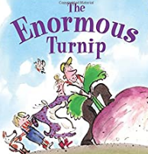  Harvest |  | 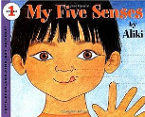
Term 1 | Writing Opportunities:  Labels: map of the school | Writing Opportunities:  Labels: emotion jars |  | Writing Opportunities:  Labels: family portraits |  | Writing Opportunities:  Labels: name writing |  | Writing Opportunities:  Labels: body parts |  | Writing Opportunities:  Speech Bubbles  Story-telling |  | Writing Opportunities:  Lists: what do you see/hear/feel/smell/taste?
Term 1 | Key Vocabulary:  School, classroom, inside, outside, teacher, learning, looking, listening, thinking | Key Vocabulary:  Emotions, feelings, happy, sad, scared, fear, angry, calm, nervous, shy, worried, excited, lonely, confused, love |  | Key Vocabulary:  Family, family 0.0member names, love, help, protect, care, team |  | Key Vocabulary:  Friends, same, different, compare, similar, opposite words (e.g. young, old, tall, short) |  | Key Vocabulary:  Body, head, turn, neck, bend, shoulders, raise, arms, wave, hands clap, chest, thump, back, arch, hips, wiggle, knees, bend, legs, kick, foot, stomp, toe, wiggle, skin, bones, skull, healthy |  | Key Vocabulary:  Enormous, big, bigger, biggest, large, tiny, small, smaller, smallest, medium, middle sized, turnip, pulled, heave, budge, stuck, thud, thump, thwack, bump |  | Key Vocabulary:  Senses, see, sight, look, eyes, hear, hearing, sound, ears, smell, smelling, sniff, nose, taste, tasting, tongue, touch, touching, fingers, skin
Term 2 | Celebrations  Bonfire Night, Autumn, Birthdays, Winter, Diwali, Christmas
Term 2 | 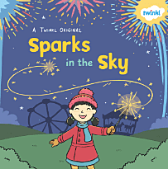  Bonfire Night | 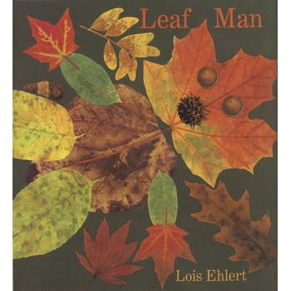 |  | 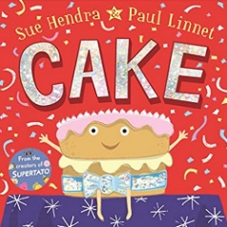  Birthdays |  | 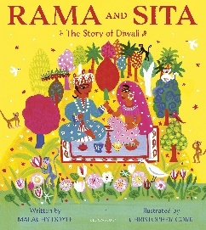  Diwali |  | 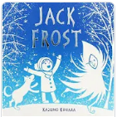 |  | 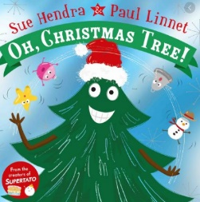
Term 2 | Writing Opportunities:  Onomatopoeia | Writing Opportunities:  Autumn writing and lists |  | Writing Opportunities:  Lists: what do you need for your party?  Invitations |  | Writing Opportunities:  Story-telling |  | Writing Opportunities:  Wanted Posters |  | Writing Opportunities:  Lists: what will you put on your tree?  Letters: To Father Christmas
Term 2 | Key Vocabulary:  Bonfire, fireworks, sparklers, safe, safety, special, gloves, fire, hot, dangerous, celebration | Key Vocabulary:  Autumn, weather, cold, clouds, rain, wind, rustle, crunchy, brow, orange, yellow, red, green, change, season |  | Key Vocabulary:  Birthday, special, celebration, invitation, party, occasion, suddenly |  | Key Vocabulary:  Special, celebration, Diwali, Rama, Sita, story, diwa lamp, Hindu, believe, festival of light, rangoli, mehndi, pattern, colours, fireworks |  | Key Vocabulary:  Winter, cold, snow, frost, Jack Frost, magical, season, change, weather |  | Key Vocabulary:  Special, celebration, decorations, gifts, baubles, Christmas tree, food, caring
Term 3 | People  Super Heroes, Mother’s Day, Mermaids, Builders, Traditional Tale: The Gingerbread Man, Chinese New Year.
Term 3 | 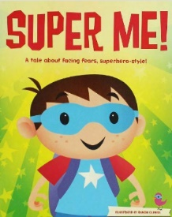 |  | 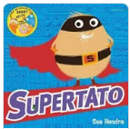 |  | 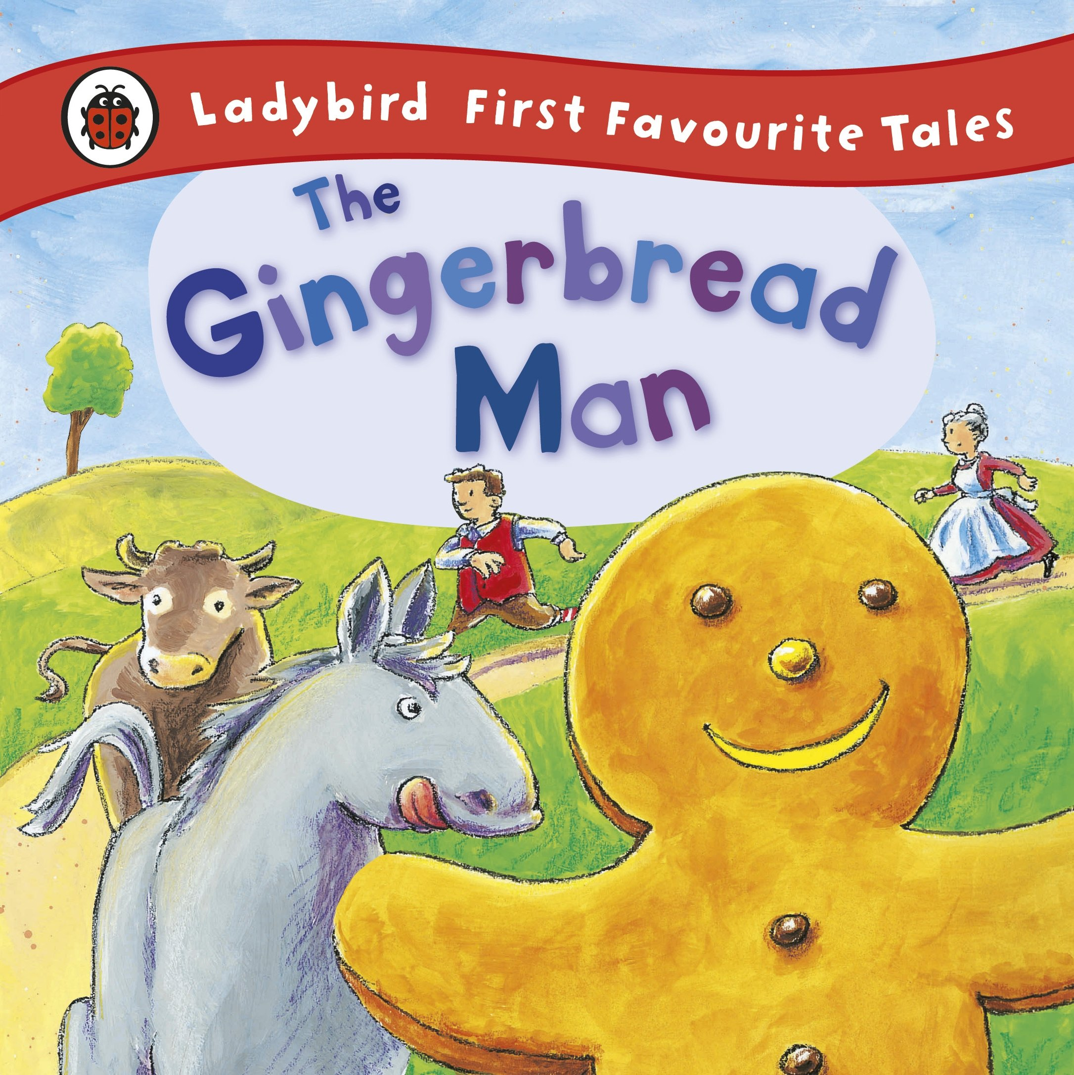 |  | 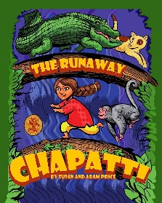 |  | An inclusive text on class development |  | 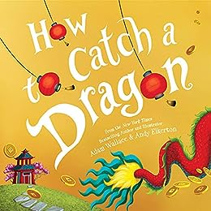
Term 3 | Writing Opportunities:  When I put on my super cape, how will I feel? |  | Writing Opportunities:  Speech Bubbles |  | Writing Opportunities:  Story-telling,  Story writing |  | Writing Opportunities:  Story-telling,  Story writing |  |  |  | Writing Opportunities:  Simple sentences:  Writing fortune cookie messages
Term 3 | Key Vocabulary:  Confident, brave, patient |  | Key Vocabulary:  Vegetable names, protect, rescue, speech bubbles, comic book |  | Key Vocabulary:  Fairy Tale, story, characters, villain, beginning, middle, end, “Stop! You look good enough to eat!” “Run, run, as fast as you can! You can’t catch men, I’m the Gingerbread Man!” |  | Key Vocabulary:  AFairy Tale, story, characters, villain, beginning, middle, end, |  |  |  | Key Vocabulary:  Chinese New Year, celebration, fireworks, traditional, dragon, fortune cookie
Term 4 | People Who Help Us  People Who Help Us, Pancake Day, Traditional Tale: Goldilocks and the Three Bears
Term 4 | 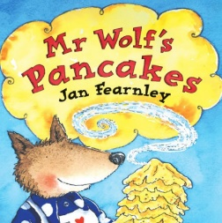  Pancake Day |  | 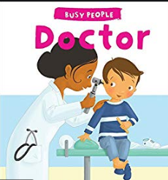 |  | 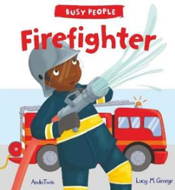 |  | 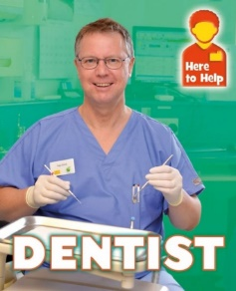 |  | 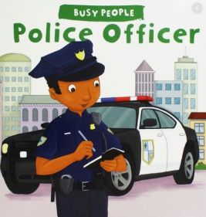 |  | 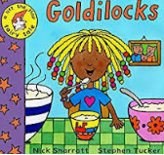
Term 4 | Writing Opportunities:  Recipe writing |  | Writing Opportunities:  Simple sentences: Doctor notes |  | Writing Opportunities:  Simple sentences: Firefighter Reports, fire safety instructions |  | Writing Opportunities:  Simple sentences: Dentist notes, poster writing |  | Writing Opportunities:  Simple sentences: Police Reports, why are they in jail? |  | Writing Opportunities:  Story-telling,  Story writing,  Wanted posters
Term 4 | Key Vocabulary:  Recipe, mixture, batter, pancake, whisk, frying pan, |  | Key Vocabulary:  Doctor, nurse, stethoscope, medicine, notes |  | Key Vocabulary:  Firefighter, safety, fire alarm, helmet, fire engine, hose, uniform |  | Key Vocabulary:  Dentist, teeth, clean, toothbrush, toothpaste, floss, mouthwash, gum, healthy |  | Key Vocabulary:  Police officer, safety, protect, police car, uniform |  | Key Vocabulary:  Once Upon a Time, characters, beginning, middle, end, “Whose been sitting in my chair” “it was just right”
Term 5 | Animals and the Environment  Birds, Reptiles, Recycling, Habitats, Zoo Animals, Traditional Tale: The Three Billy Goats Gruff
Term 5 | 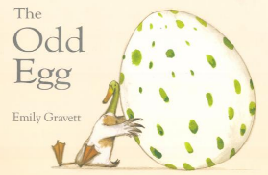 |  | 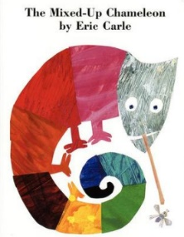 |  | 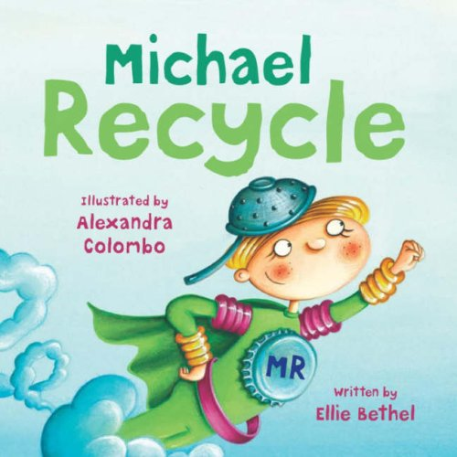  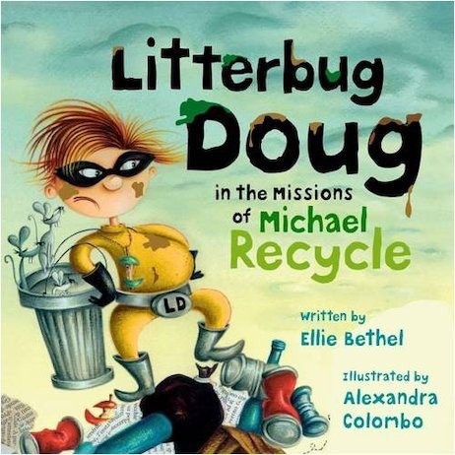 |  | 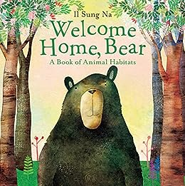 |  | 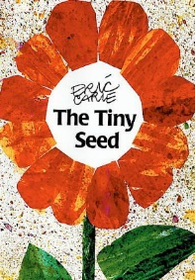 |  | 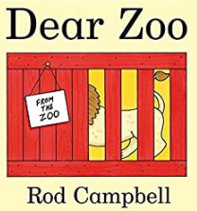
Term 5 | Writing Opportunities:  Simple sentences: what is inside your egg? |  | Writing Opportunities:  Labels: what does your chameleon turn into? |  | Writing Opportunities:  Lists:  What can be recycled?  Poster writing |  | Writing Opportunities:  Simple sentences:  Which animal could live in this habitat? |  | Writing Opportunities:  Simple sentences: what does your seed need to grow? |  | Writing Opportunities:  Story-telling,  Story writing  Simple Sentences: what did the zoo send to you?
Term 5 | Key Vocabulary:  Egg, shell, hatch, bird, reptiles |  | Key Vocabulary:  reptiles, chameleon, lizard, camouflage, colour |  | Key Vocabulary:  Recycling, materials, metal, glass, wood, paper, plastic |  | Key Vocabulary:  Habitat, environment, homes, desert, artic, ocean, forest, jungle, temperature |  | Key Vocabulary:  Seed, grow, water, sun light, temperature, soil, stem, petals, leaves |  | Key Vocabulary:  Dear, zoo, animals’ names, sizes, letter
Term 6 | Food  Rhyme, Food, Father’s Day, Transition
Term 6 | 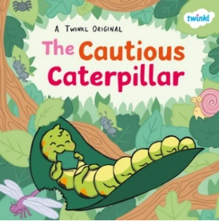 |  | 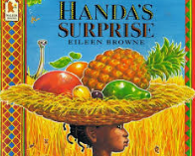 |  | 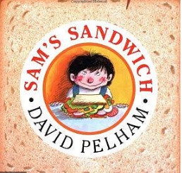 |  | 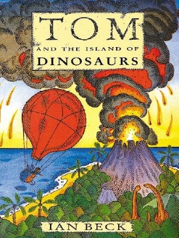  Longer term project |  | Poetry to be confirmed
Term 6 | Writing Opportunities:  Simple sentences: information about yourself |  | Writing Opportunities:  Instruction Writing: How to make Fruit Kebabs |  | Writing Opportunities:  Recipe writing  Menu writing |  | Writing Opportunities:  Instruction Writing: Letter writing  Escape plans  Recounts  Maps labels
Term 6 | Key Vocabulary:  Cautious, emotions |  | Key Vocabulary:  Food, fruit, healthy, fruit names, instructions, bossy sentences, equipment |  | Key Vocabulary:  Recipe, menu, food, healthy, insects, insect names |  | Key Vocabulary:

