Term 3 and 4 Year 5
RE Vocabulary
Vocabulary | Definition | Ideas
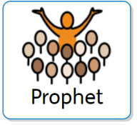 | A messenger of God
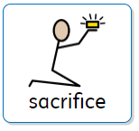 | To choose to give something up
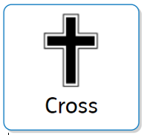 Christianity | A Holy symbol of Christianity
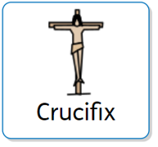 Christianity | A Holy symbol of Christianity
Christianity | The 6th day of Holy week
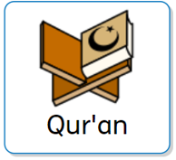Islam | The Holy text of Islam
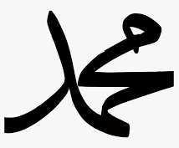  Muhammad  Islam | The prophet of Allah

