Term 3 and 4 Year 6
RE Vocabulary
Vocabulary | Definition | Ideas
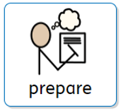 | To get ready for an event
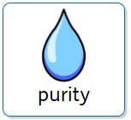 | Freedom from dirt
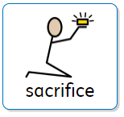 | To choose to give something up
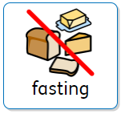 | To not eat
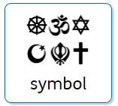 | A picture that represents a faith
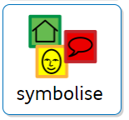 | A picture that can represent a meaning
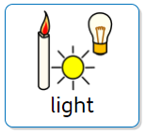 | Used to symbolise Good (light) over Evil (darkness)
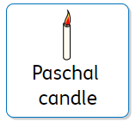  Christianity | A candle lit at Lent. A Christian symbol
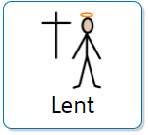  Christianity | A Holy time in the Christian calendar. Christians will choose to give something up.
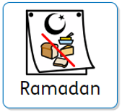Islam | A Holy time. The 9th Month of the Islamic calendar.
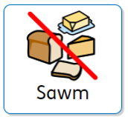  Islam | The 4th Pillar of Islam. Muslims will not eat during day light hours during this time.
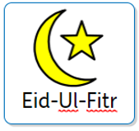 Islam | A Holy celebration at the end of Sawm.

