Term 3 and 4 Year 3
RE Vocabulary
Vocabulary | Definition | Ideas
 | The freedom to have your own thoughts
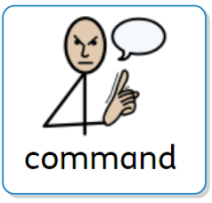 | An instruction
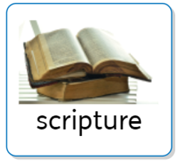 | A Holy text
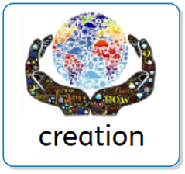 | How the world was created
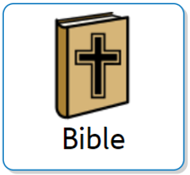  Christianity | The Holy text of Christianity
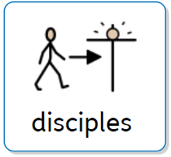  Christianity | Jesus’ special friends
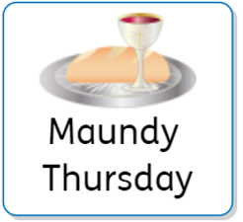  Christianity | The 5th day of Holy Week
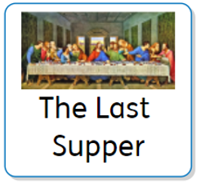  Christianity | Jesus’ last meal
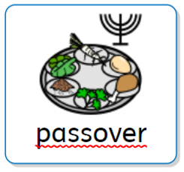  Judaism | Jewish feast
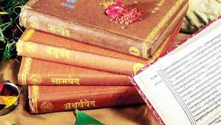  Vedas  Hinduism | The Holy text of Hinduism

