Term 3 and 4 Year 4
RE Vocabulary
Vocabulary | Definition | Ideas
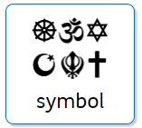 | A picture that represents a faith
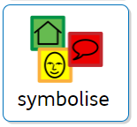 | A picture that can represent a meaning
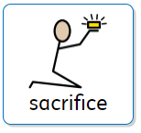 | To choose to give something up
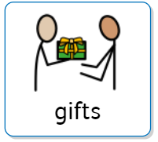 | Something special that you give to someone else
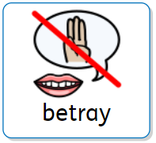 | To say or do something unkind to hurt someone else
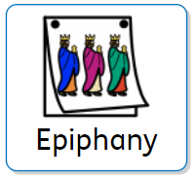 Christianity | The 6th of January.  The Three Wise Men travel to see baby Jesus in the stable
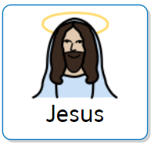 Christianity | The Son of God
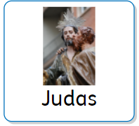 Christianity | One of Jesus’ disciples
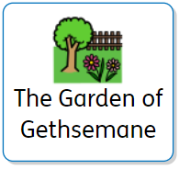 Christianity | A Holy place of prayer.  Where Judas betrays Jesus

