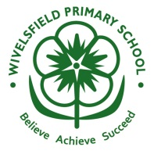

Free School Meals

Information from East Sussex County Council

Infant Free School Meals
Your child gets free school meals if they’re in:
- reception class
- year 1
- year 2
If you get any of the benefits listed below, your child’s school will get more funding which they can use to give your child extra support. If the school gets the additional funding then this can also be used for music lessons, an extra curricular club and for school trips.
https://www.eastsussex.gov.uk/educationandlearning/schools/school-life/meals/free/
- Universal Credit – your household income must be less than £7,400 a year (after tax and not including any benefits you get)
- Income Support
- Income-based Jobseekers Allowance
- Income-related Employment and Support Allowance
- Support under Part VI of the Immigration and Asylum Act 1999
- The Guaranteed element of State Pension Credit
- Child Tax Credit only, if your annual household income (assessed by HM Revenue & Customs) isn’t over £16,190. Anyone getting Working Tax Credit won’t get free meals regardless of income.
- Working Tax Credit run-on – paid for 4 weeks after you stop qualifying for Working Tax Credit

