Wivelsfield Primary School
Wivelsfield Wrens Nursery is opening in September 2023
Registration is now open

Wrens Nursery
Wrens Nursery has 24 spaces for children aged 2 - 5 years. It is accommodated in a stand-alone building, with its own entrance, allowing easy access for parents and carers throughout the day. However, the nursery has easy access to the main building so children attending can be very much part of the whole school community.
Wrens Nursery has its own dedicated outdoor area, with artificial grass and an extensive canopy, meaning it can be used whatever the weather. There is a linking gate to the Reception Class outdoor classroom, allowing preschoolers access to this area and all nursery children will be able to use the fantastic facilities the school has to offer. These include our vast field and playground, forest school area, pond, and the school hall. The children will also be able to enjoy meeting visitors to the school such as the Fire and Rescue Service and join in other activities like world book day and charity events such as our Elf Run.

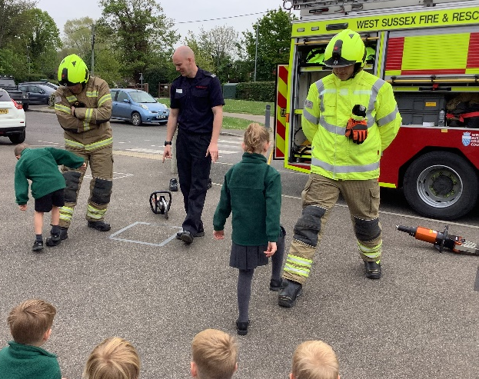

Age of Admittance
We provide care for children aged 2 - 5 years over 38 weeks of the year aligned with Wivelsfield School term dates.
Opening hours and funding
Wivelsfield Wrens is open during Wivelsfield School term times and offers the following sessions:
 | Morning Session | Lunchtime** Session | Afternoon Session | After school session ** | After school session **
Time | 8.30 - 11.30 | 11.30 - 12.30 | 12.30 - 15.30 | 15.30 -16.15 | 16.15 - 17.00
Length of session | 3 hours | I hour | 3 hours | 45 minutes | 45 minutes
EYEE Funding available | Yes + Consumable charge | No | Yes + Consumable charge | No | No
Cost of private funding 2 year old’s | £21.00 (fully inclusive rate) | £7.00 | £21.00 (fully inclusive rate) | £5.50 | £5.50
Cost of private funding 3 and 4 year old’s | £18.00 (fully inclusive rate) | £6.00 | £18.00 (fully inclusive rate) | £5.50 | £5.50

Nursery charges will be updated annually.
**Details of arrangements for after school sessions will follow shortly
Consumable Charge (EYEE Sessions only): There will £1.00 charge per EYEE session to cover wipes, snack, sun cream etc. If you are concerned about the additional consumable charge, please talk to the manager in the first instance.
Nappies must be provided by parent/carer.
A hot meal will be available at lunchtime at an additional cost or parent/carers can provide a packed lunch.
Funding for 2 year old children
Some 2 year olds are eligible to access 15 funded hours per week the funding period following their second birthday. For further information and how to apply can be found at: Help with childcare costs | East Sussex County Council
Funding for 3 and 4 year old children:
From the funding period following their child’s third birthday, all children can access 15 funded hours per week.
Working parents who meet the criteria could be entitled to 30 Hours Extended offer providing an additional 15 hours free childcare over 38 weeks for their 3 and 4 year old’s. More information on eligibility can be found at: https://www.childcarechoices.gov.uk
For more information about funded places for 2, 3 and 4 year olds please follow this link:
Help with childcare costs | East Sussex County Council
Late Collection Fee
If you are 10 - 15 minutes late to collect your child; you will be charged £1.00 for every minute over your booked time.
If you are more than 15 minutes late, there will be a charge of £7.00.
If we are notified of extreme circumstances, these charges may be waived.

Other Information
Communication and Tapestry
We place huge importance on communication between Wrens Nursery and parents and carers. The more we know about and understand your child, the better we can help them to settle, be happy and learn. As well as plenty of opportunity to catch up with staff at drop off and collection, we also use Tapestry to capture your child’s experiences to share with you. Tapestry is an online learning journal for both the nursery staff and parents/carers to use and creates a wonderful lasting memory of your child’s time at Wivelsfield Wrens. We continue to create this online journal if your child is admitted to our Robins Reception Class.

Key Person
All children will have a named person, called a key person. A key person has responsibility for a small group of children and helps those children, in particular, to feel safe and cared for. They respond sensitively to the children’s feelings and behaviours and meet emotional needs by giving reassurance, such as when they are new to a setting or class and supporting the child’s well-being. The key person supports physical needs too, helping with issues like nappy changing, toileting and dressing. That person is a familiar figure who is accessible and available as a point of contact for parents and one who builds relationships with the child and parents or carers.
Each Key Person also completes a ‘Learning Journey’ on Tapestry for the child, which you are able to access.

